**1.17) Create a program to get count of HTML tags. Eg: <div> = 2, <p> =4.**

**Consider elements from the body tag only.**

<!DOCTYPE html>

<html id="h">

    <head id="H1"><title>1.5</title>

        <style>

            body{

                background: pink;

            }

            div{

                display: block;

               align-items: center;

            }

            #demo{

                padding: 30px;

                padding-top: 50%;

                padding-left: 50%;

            }

            button{

                padding: 30px;

                margin: 20% 40% ;

                border:  4px solid black;

            }

        </style>

    </head>

    <body id="H2">

        <div></div>

        <div id="try"><h1><a href=""></a></h1></div>

        <div id="try2"><h1><p></p></h1></div>

        <div id="try3"></div>

        <p id="display"></p>

  <button onclick="show()"><h1>click here</h1></button>

        <script type="text/javascript">

                 //d -recursive calling

        let  show=() =>{

            let TagStore=Array()

               let j=0;

               let show1=()=>{

                   return GetElement(document.body,0);

               }

               let GetElement=(root,level)=>{

                   let type=window.NODE ?NODE.ELEMENT_NODE:1;

                   if(root.nodeType==type){

                       setElement(level,root.nodeName)

                       let child=root.children;

                       for(let i=0;i<child.length;i++){

                           GetElement(child[i],level+1);

                       }

                   }

               }

               let setElement=(level,node_name)=>{

                  let n=TagStore.includes(node_name);

                        TagStore[j]=node_name;

                    j=j+1;

                   }

               show1()

              let   A="";

              let Check=Array();

               for(let i=1;i<TagStore.length;i++){

                   let   count=0;

                   if(Check.includes(TagStore[i])==true){}

                  else{

                   for(let j=0;j<TagStore.length;j++){

                         if(TagStore[i]==TagStore[j]){

                             count=count+1;

                             Check[i]=TagStore[i];

                             }

                    }

                    A+=TagStore[i]+"-"+count+"\n";

                    document.getElementById("display").innerHTML+="\n"+TagStore[i]+"-"+count+"\n";

                  }

                  } alert(A);

             }</script>

     </body>

</html>

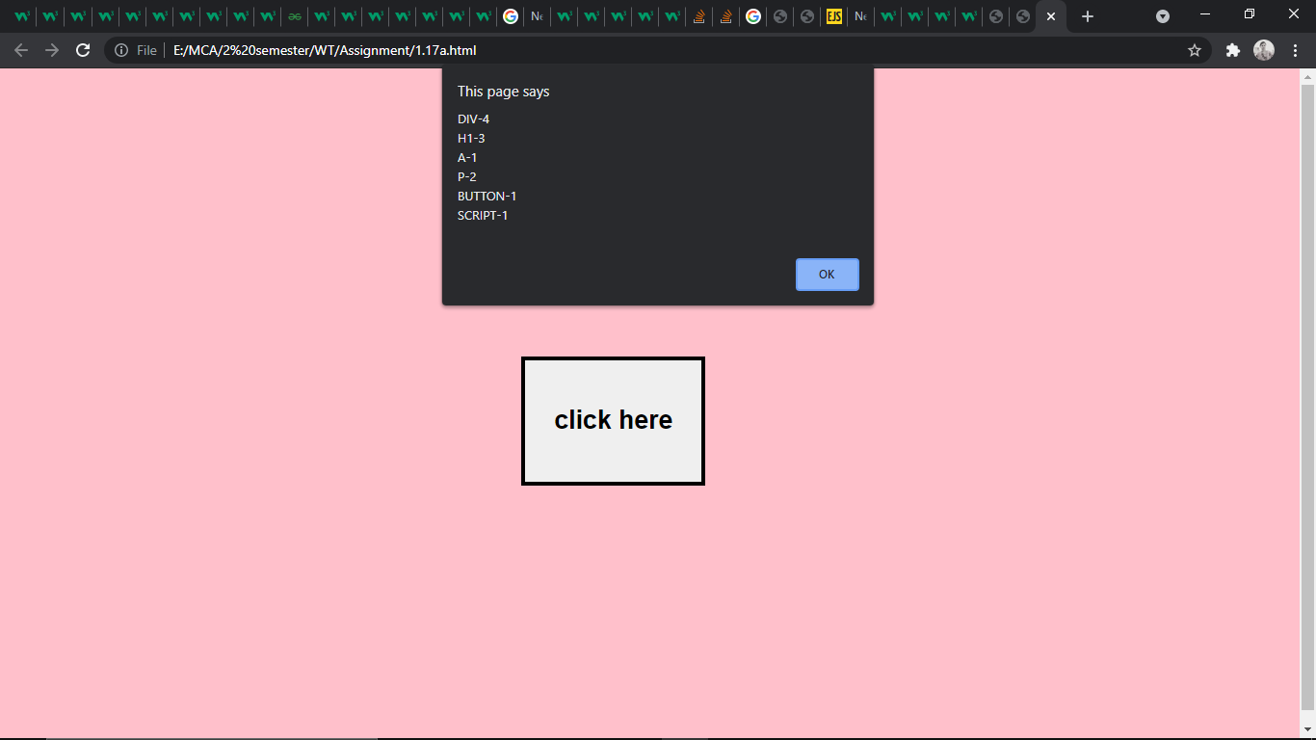

**1.18) Create a program to demonstrate handling of all mouse events using addEventListener() method.**

<!DOCTYPE html>

<html>

<head><title>1.17</title>

<style>

    body{

       background-color:skyblue;

        background-repeat: no-repeat;

        box-sizing: border-box;

    }

    .column  {

  float: left;

  width: 28.33%;

  padding:5px 5px 5px 40px;

  background: palevioletred;

  margin: 10px;

}

/* Clearfix (clear floats) */

.row {

  content: "";

  clear: both;

  display: flex;

  /*display: table;*/

}

div.column1{

   margin-top: 35px;

   margin: 10px;

}

.ReLoad{

    margin:auto;

    margin-left: 40rem;

}

img{

    margin-top: 20px;

    width: 100%

}

.para1{

    text-transform: uppercase;

    text-align: center;

}

button{

    padding: 8px;

    border-radius: 10%;

    background:grey;

    margin-top: 70px;

    }

    </style>

</head>

<body>

        <div id="mainclass">

                    <!--mouse down and mouse up events-->

           <div class="row">

               <div class="column" id="coloum">

                   <p><h2>Mousedown up</h2>

                   <p id="A"></p>

                        <img src="aa.jpg" id="image" style="width:200px; height:200px"; />

                        </p>

                        </div>

        <!--Mouse Over and mouse out-->

               <div class="column column1" id="coloum1">

                   <p><h2>Mouseover out</h2>

                <p id="A1"><h1></h1>

                <img src="dd.jpg" id="image0" style="height: 200px; width:200px;"  />

                </p>

                </p>

                </div>

                <div class="column column2" id="coloum2">

                    <p><h2>Mousemove and click</h2></p>

                 <h1><p id="A2"></p></h1>

                 <button id="but" >click here to stop</button>

               </div>

                 </div>

                <div class="para" >

                   <h1> <p class="para1" id="para1">Double click here to change background color

                    </p></h1></div>

        </div>

        <div>

            <button class="ReLoad" onClick="window.location.reload();"> Reload page</button onclick="window.location.reload();">

        </div>

<script>

    /*mouse down mousup*/

document.getElementById("image").addEventListener("mousedown",function(){

document.getElementById("A").innerHTML="<h1> Mousedown<h1>";

document.getElementById("image").src="bb.jpg";

});

document.getElementById("image").addEventListener("mouseup",function(){

    document.getElementById("A").innerHTML="<h1> Mouseup<h1>";

    document.getElementById("image").src="aa.jpg";

});

/*mouseover mouseout*/

let OverOut=(Img,t)=>{

    document.getElementById("image0").src=Img;

    document.getElementById("A1").innerHTML="<h1>"+t+"<h1>";

  }

document.getElementById("image0").addEventListener("mouseover",function(){

    OverOut("aa.jpg"," mouseover")});

 document.getElementById("image0").addEventListener("mouseout",function(){

    document.getElementById("image0").addEventListener("mouseout",function(){

    OverOut("dd.jpg"," mouseout")});

});

/*ondbclick*/

function myFunction(c1,c2,event) {

    document.body.style.background=c1;

    document.getElementById("coloum").style.background=c2

    document.getElementById("coloum1").style.background=c2;

    document.getElementById("coloum2").style.background=c2;

  document.getElementById("para1").innerHTML= event

}

document.getElementById("para1").addEventListener("dblclick",function(){ myFunction("#ff66b3","#b3b3cc","<h2>background changed</h2>")},false);

/*document.getElementById("para1").addEventListener("dblclick",function(){ myFunction("#00a3cc","#ff0055","<h2>back to normal</h2>")},false)*/

/*mousemoove*/

let n=0;

function Fun()

    {

       document.getElementById("A2").innerHTML=n+=1;

    }

let RemoveEvent=()=>{

        document.getElementById("coloum2").removeEventListener("mousemove",Fun);

}

document.getElementById("coloum2").addEventListener("mousemove",Fun);

document.getElementById("but").addEventListener("click",RemoveEvent);

</script>

</body>

</html>

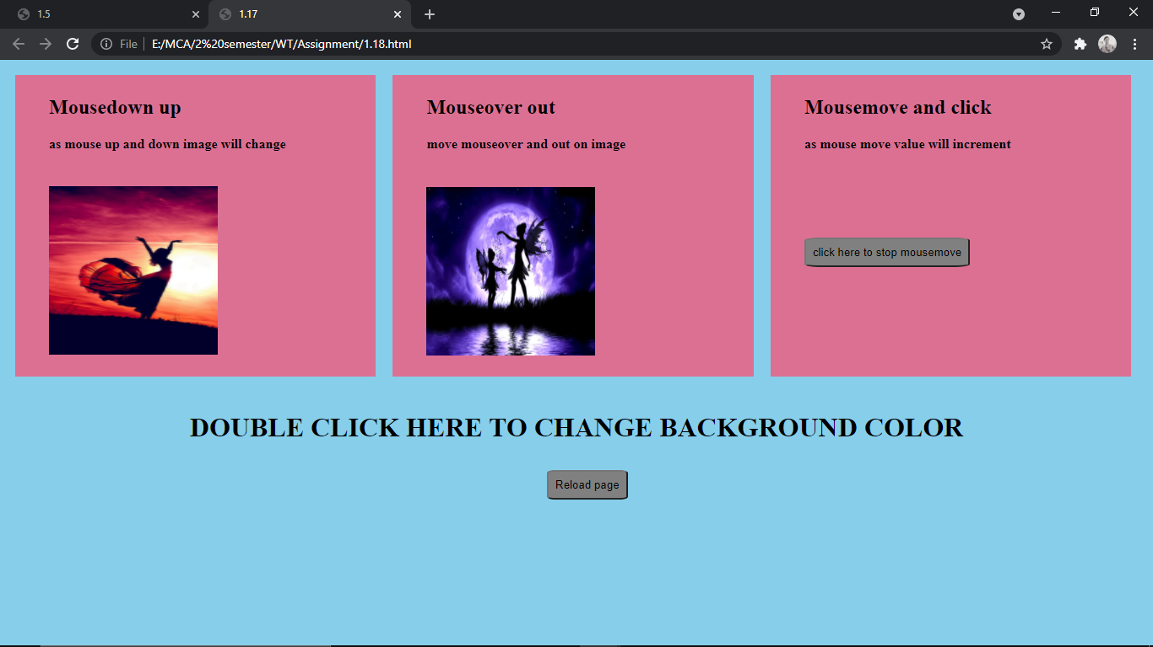

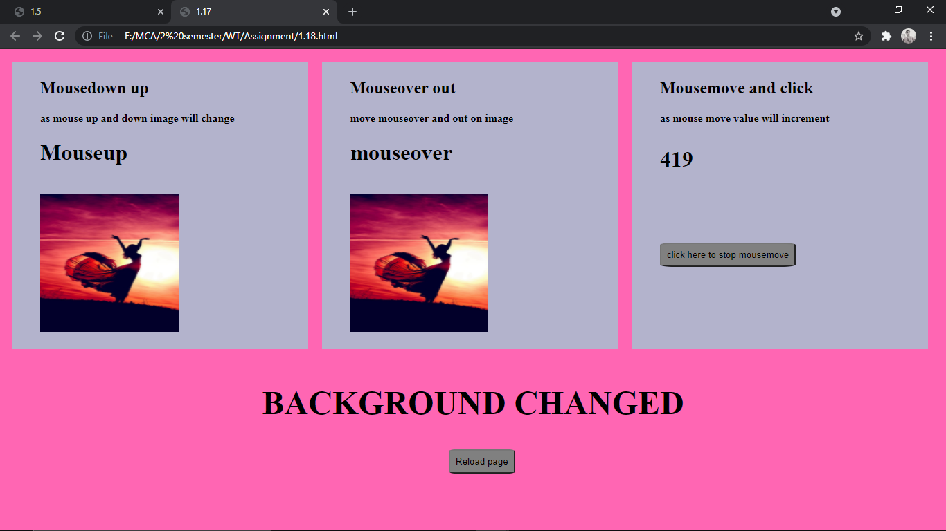

**1.19) Demonstrate capturing, bubbling and target event propagation**.

<!DOCTYPE html>

<html lang="en">

    <head>

        <title>

            event propagation 1.19

        </title>

        <style>

            div.container{

                align-items: center;

                padding: 10% 10%  15%   20%;

                display: flex;

            }

            button{

                align-items: center;

                padding: 30px;

                margin: 0px

            }

            h4{

                padding: 0%;

                margin: 0%  ;

            }

 </style>

    </head>

        <body>

            <div class="container">

                <div id="a1" style="background:red;margin:20px; padding:15px 10px 10px 10px;" ><h4>first</h4>

                    <div id="a2" style="background: powderblue;padding:20px" ><h4>second</h4>

                        <div id="a3" style="background: royalblue;padding:15px;"><h4>third</h4>

                <button id="click1" class="click1" >clck1</button>

                </div>

                    </div>

                         </div>

                <div id="b1" style="background:red;margin:20px;padding:15px 10px 10px 10px;"><h4>first</h4>

                    <div id="b2" style="background: powderblue; padding: 20px;"><h4>second</h4>

                        <div id="b3" style="background: royalblue;padding: 15px;"><h4>third</h4>

                            <button id="click2" class="click2" >clck2</button>

                        </div>

                    </div>

                </div>

                <div id="c1" style="background:red;margin:20px;padding: 15px 10px 10px 10px;"><h4>first</h4>

                    <div id="c2" style="background: powderblue;padding: 20px;"><h4>second</h4>

                        <div id="c3" style="background: royalblue; padding:15px;">

                         <h4 style="padding-top:0px;">third</h4><button id="click3" class="click3" >clck3</button>

                        </div>

                    </div>

                </div>

            </div>

            <script>

            /*section A*/

            let ShowResult=(n,m)=>{

                alert("you clicked\nbutton "+n+m);

                console.log(n+"-"+m);

            }

            document.getElementById("a1").addEventListener("click",function()

                {

                    ShowResult("click1  ","first");

                },false);

                document.getElementById("a2").addEventListener("click",function()

                {

                    ShowResult("click1  ","second");

                    console.log("stop propagation");

                    event.stopPropagation();

                },true);

                document.getElementById("a3").addEventListener("click",function()

                {

                    ShowResult("click1  ","third");

                },false);

                /*section B*/

                document.getElementById("b1").addEventListener("click",function()

                {

                    ShowResult("click2  ","first");

                },false);

                document.getElementById("b2").addEventListener("click",function()

                {

                    ShowResult("click2  ","second"+" -target listener")

                },true);

                document.getElementById("b3").addEventListener("click",function()

                {

                    ShowResult("click2  ","third");

                 },false);

             /*section 3*/

             document.getElementById("c1").addEventListener("click",function()

                {

                    ShowResult("click3 ","first");

                },true);

                document.getElementById("c2").addEventListener("click",function()

                {

                    ShowResult("click3  ","second");

                },true);

                document.getElementById("c3").addEventListener("click",function()

                {

                    ShowResult("click3  ","third");

                 },true);

                </script>

                    </body>

                </head>

            </html>

